**The COVID-19 ETL project**

1. Basic viewpoint of the project:

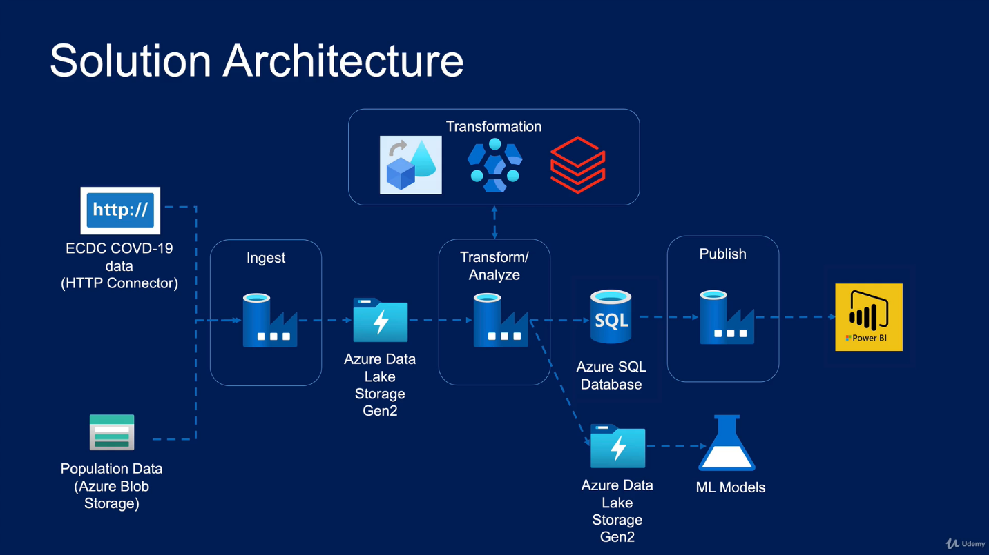

Out of course